IIHT
FLIGHT BOOKING
Contents
1 Problem Statement 2
2 WIREFRAMES 3
3 Application Architecture 4
3.1 Microservice Architecture (Compute and Integration/Presentation/Networking and Content Delivery): 4
4 Cloud Architecture 5
5 Tool Chain 5
6 Business Requirements: 7
7 Proposed Rest Endpoints to be exposed 8
7.1 Rest APIs: 8
8 Key Rubrics/Expected Deliverables 8
8.1 Debugging & Troubleshooting 9
8.2 Code Quality/Optimizations 9
9 Platform 9
10 Methodology 9
10.1 Agile 9

Problem Statement
Build a software system which lets user search for a Flight Ticket and book it & includes Admin related activities. User can also cancel or update the Ticket.
Below are the different roles, which need to be supported by above Software System.
- User
- Admin
The scope includes developing the application using tool chain mentioned below.

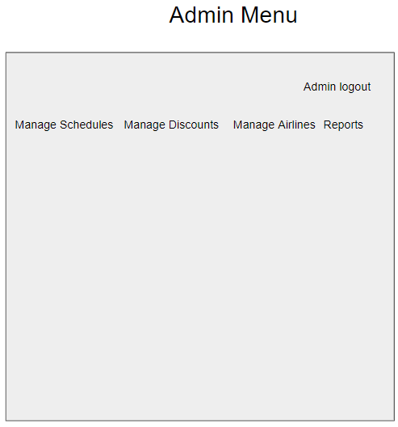
WIREFRAMES
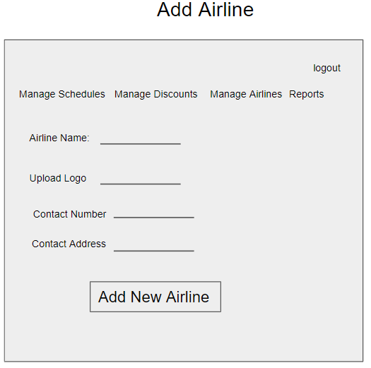
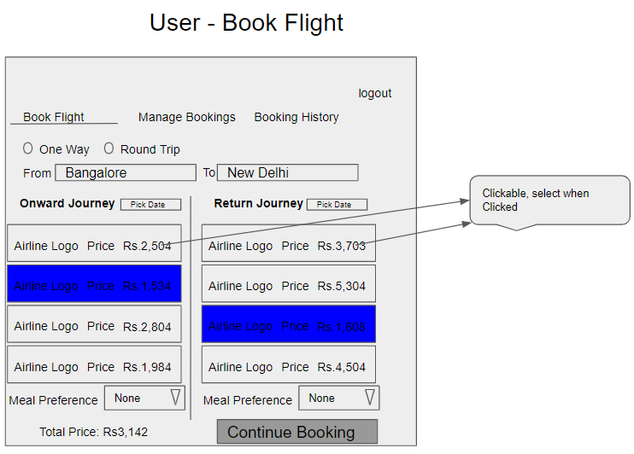
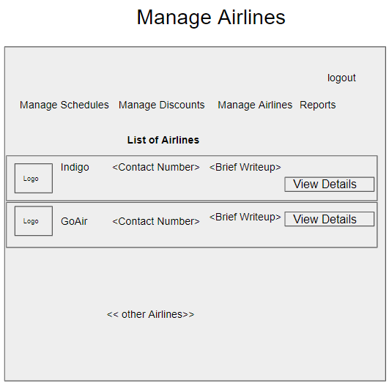
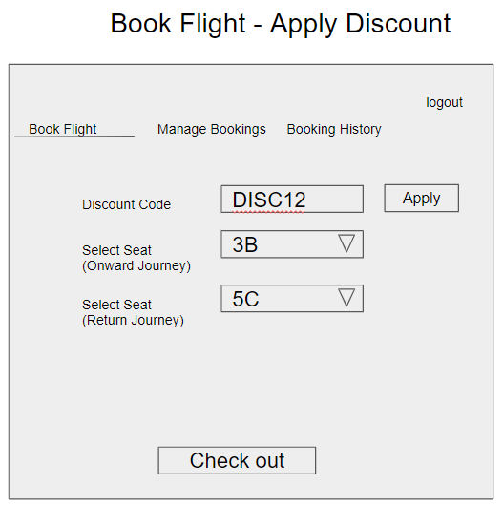
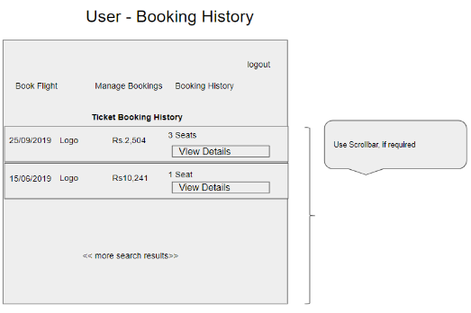
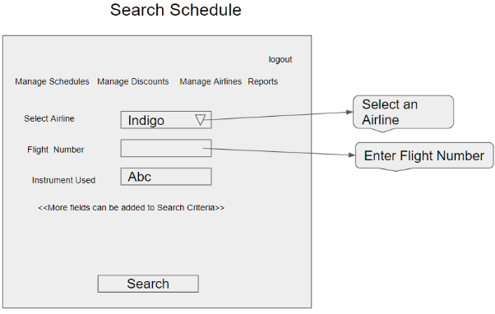
UI needs improvisation and modification as per given use case.
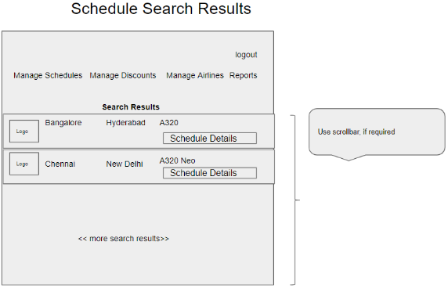
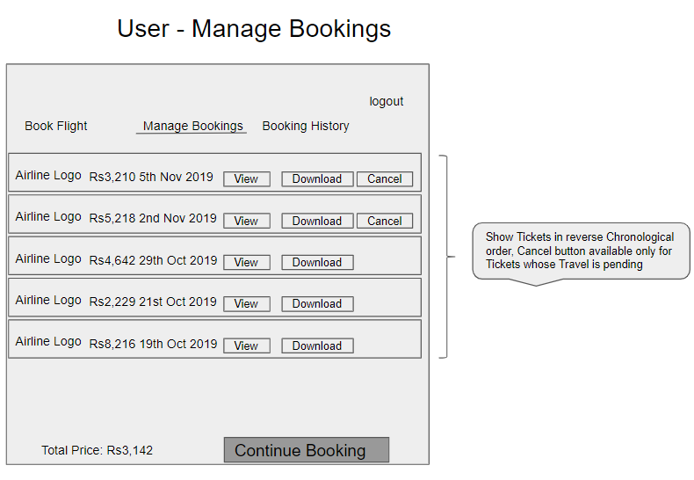

Application Architecture

Microservice Architecture (Compute and Integration/Presentation/Networking and Content Delivery):

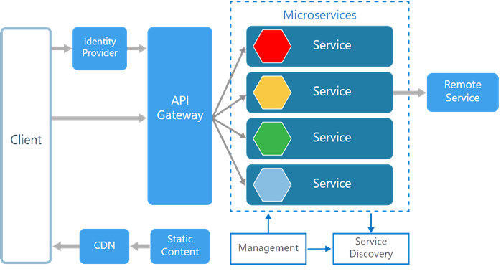

Cloud Architecture

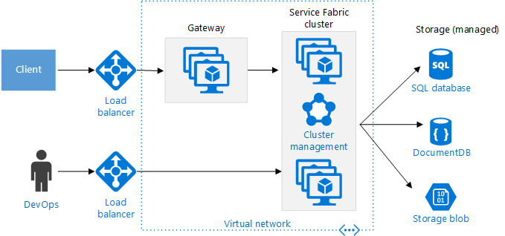

Tool Chain
Competency | Skill | Skill Detail
Engineering Mindset | Networking and Content Delivery
 | DevOps
 | Secure Coding
 | Code Quality | SonarCube
Programming Languages | Application Language | C#
Products & Frameworks | Presentation | Angular
 |  | Javascript/Typescript
 | Networking and Content Delivery | Ocelot
 | Security and Identity | OpenIAM
 | Compute & Integration | Dotnet Core Web API
 |  | Kafka / RabbitMQ
 | Database & Storage | MS SQl Server
 | Governance & Tooling | Git
 |  | NUnit / XUnit
 |  | Moq
 | Versioning | API Versioning
Engineering Quality
Platform | Cloud Tools | Azure VM
 |  | Azure SQL Server
 |  | Azure Functions
 |  | Azure API Gateway
 |  | Azure Load Balancer

Business Requirements:
As an application developer, develop microservices with below guidelines:
User  Story # | User Story Name | User Story
US_01 | User Mode | - User can search for a Flight based on date/time, from place/to place, one way or round trip  - Each Search result need to display Flight Date/time, Airline Name/Logo, Price(to & round trip – TBD)  - From Search results, User should be able to select a specific Flight and go ahead and complete Ticket Booking by providing below details  - Name and Email ID  - Number of seats to book.  - Details of each passenger (NAME:GENDER:AGE)  - Opt for Meal(Veg/Non veg)  - Select Seat Number(s)  - On successful Ticket Booking, PNR number need to be generated, it should be possible to download TicketBooking can be done a Logged in User only  - With email id user should be able to  - view History of Ticket Bookings,  - Cancel a Ticket only prior to a day(24 hrs) before journey date.  - With PNR number view the booked ticket details
US_02 | Admin Mode | - Admin shall be able to login/logout.  - There can be pre-defined username/password for Admin.  - Admin shall be able to add/block an Airline. When Airline is Blocked, Flights belonging to that Airline will not be shown in Ticket Search results.  - Admin shall be able to add Inventory/Schedule of an existing Airline by specifying below details:  - flight number  - Airline  - From Place  - To Place  - Start date time,  - End date time,  - Scheduled Days(Daily, Week Days, Week Ends, For specific days specify the list of Days like Mon, Wed)  - Instrument used(A320, A320 neo, etc…)  - Total number of business class Seats  - Total number of non-business class Seats  - Ticket cost (consider taxes and other charges),  - number of rows,  - meal(none, veg, non veg)

Proposed Rest Endpoints to be exposed

Rest APIs:
POST | /api/v1.0/flight/airline/register | New airline booking
POST | /api/v1.0/flight/admin/login | Admin login
POST | /api/v1.0/flight/airline/inventory/add | Add Inventory/Schedule of an existing Airline
POST | /api/v1.0/flight/search | Searches for flight
POST | /api/v1.0/flight/booking/{flightid} | Book ticket
GET | /api/v1.0/flight/ticket/{pnr} | Get Booked ticket details based on PNR
GET | /api/v1.0/flight/booking/history/{emailId} | Get Booked tickets history based on Email ID
DELETE | /api/v1.0/flight/booking/cancel/{pnr} | Cancel a booked ticket

Key Rubrics/Expected Deliverables
As an application developer:
  - Develop the application as a microservice architecture.
  - Ensure layer project Structure with proper naming conventions and model classes.
  - Use application.json file to maintain all configuration like connection string
  - Implemented the layered structure - Controller, Interface, Service, DAO, Testing, Validation, Security etc
  - Implementation as follows:
    - Use Domain Driven Design to implement distributed architecture
    - Follow Single Data Store per microservice practice
    - Document REST endpoints with OpenAPI/ Swagger
    - Add CQRS pattern for Event Sourcing using Kafka for saving and retrieving flight details, using Kafka (producer & consumer) topics
    - Expose all rest Endpoints using a common API Gateway Ocelot
  - Secure all Rest End Points by configuring SSL Certificate for Cloud
  - Use OpenIAM to add OTP based two factor authentication for secured operations

Debugging & Troubleshooting
- Generate bug report & error logs - Report must be linked with final deliverables which should also suggest the resolution for the encountered bugs and errors.

Code Quality/Optimizations

- Associates should have written clean code that is readable
- Associate should have used the Code Analyzer (PMD/SonarQube) to ensure code quality and standard code style.

Platform
Use User Story-1 from the Business Requirements to implement the below.
      - Use Azure VM to deploy application on cloud.
      - Use Azure SQL Server as a database for the Application.
      - Use Azure Functions and DB to build a backend process for handling requests for Flight booking App.
      - Use Azure API Gateway to expose the Lambda functions built in the previous step to be accessible on public internet.
      - Use Azure LB to configure the load balancing of the instances
Note : Minimum 2APIs (UI+Backend) to be hosted in cloud

Methodology

Agile
- As an application developer, use project management tool along to update progress as you start implementing solution.
- As an Application developer specify the estimation and planning as a part of Agile process.
- As an application developer, the scope of discussion with mentor is limited to:
  - Q/A
  - New Ideas, New feature implementations and estimation.
  - Any development related challenges
  - Skill Gaps
  - Any other pointers key to UI/UX and Middleware Development

